Atomic structure, chemical bonding, Lewis structure, and 3D molecular shape
Institutional Affiliation
Student Name
Professor Name
Course
Date

Group 1
I have selected CH₄ and PCl₃ for my experiment.
Methane CH₄ is formed by nonpolar covalent bonds. This happens due to the small difference in electronegativity of carbon and hydrogen hence they share the electrons equally. And this causes the formation of a nonpolar covalent bond.
PCl₃ is formed by a polar covalent. This is due to chlorine having a higher electronegative charge than phosphorous meaning chlorine pulls the shared electrons more to itself away from the phosphorous atom. This gives rise to unshared electrons which leads to the formation of polar covalent bonds
Data table

CH₄
Chemical formula: CH₄ | Central atom: Carbon
Dot Diagram of each element:  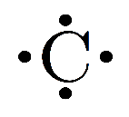 H• | Total # of electrons:  Carbon 4  Hydrogen 1(4)  The total number of atoms is 8
Lewis Structure (Dot structure) of the molecule:
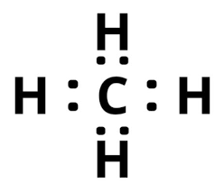

PCl₃

Chemical formula: PCl₃ | Central atom: phosphorous
Dot Diagram of each element:  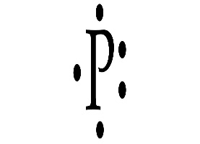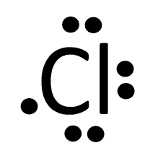 | Total # of electrons:  Phosphorous: 5  Chlorine 7  Chlorine 7  Chlorine:7  The total number of atoms is 26
Lewis Structure (Dot structure) of the molecule:
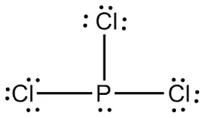

Group 2
I have selected CO₂ and NH₃ for my experiment.
CO₂ has polar covalent but its molecule is non-polar due to the presence of two oxygen atoms with equal electronegativity that pulls electrons density from the carbon atom at 180 degrees from each other. This results in no net differential charge in any direction in this molecule.
NH₃ is formed by polar covalent this happens due to the lone electrons at the top of the molecule.NH₃ forms a tetrahedral molecular geometry. All the three hydrogen atoms are arranged symmetrically around the nitrogen atom which is the base. The lone electrons form the tip of the molecular geometry of the NH₃ trigonal pyramidal.
Data table 1 (group2)
Carbon IV oxide (CO₂)
Chemical formula: CO₂ | Central atom: Carbon
Dot diagram of the elements:  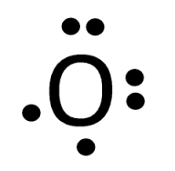 | The # of electrons:  Carbon 4  Oxygen 6  Oxygen 6  The total number of atoms is 16
Lewis structure(dot structure)
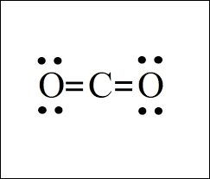

Ammonia NH₃
Chemical formula: NH₃ | Central atom: Nitrogen
Dot diagram of the elements:  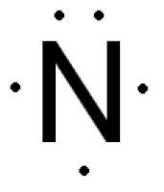 H• | The # of electrons:  Nitrogen 5  Hydrogen 1  Hydrogen 1  Hydrogen 1  Total 8
Lewis structure(dot structure)
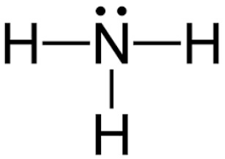

Group 3
For this experiment, I will work on these compounds: BH₃ and BeCl₂
BH₃ has a non –polar covalent bond. This is because both borane (2.04) and hydrogen (2.20) has an electronegativity that’s almost the same. Hence the bond becomes nonpolar.
BeCl₂ forms a non-polar. Beryllium’s two outer electrons bond covalently with two chlorine atoms resulting in no lone pairs. BeCl₂ structure is linear with the symmetric charge distribution around beryllium.
Data table 1 (group 3)
BH₃

Chemical formula:  BH₃ | Central atom: borane
Dot diagram of the element:  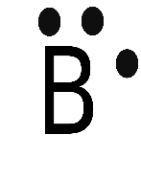 H• | The # of the atoms:  Boron 3  Hydrogen 1  Hydrogen 1  Hydrogen 1  The total number of atoms is 6
Lewis structure (dot structure)
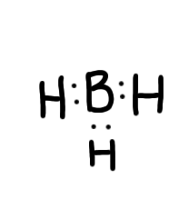

BeCl₂
Chemical formula:BeCl₂ | Central atom: beryllium
Dot diagram of the element:  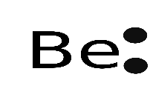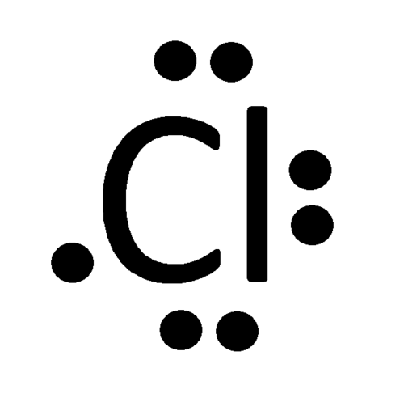 | The # of the atoms  Beryllium 2  Chlorine 7  Chlorine 7  The total number of electrons is 16
Lewis structure (dot structure)
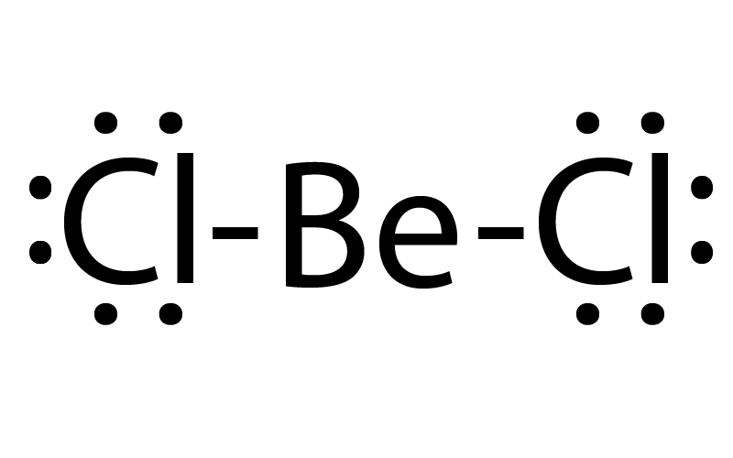

Molecular Geometry
The valence-shell, electron-pair repulsion theory there is an assumption that atoms in a molecule achieve a geometry that minimizes repulsion between electrons in the valence shell of the atom. There are steps to follow to decide the shape of a molecule using VSEPRT. The steps include.
The atom with the least electronegative must be the central atom. This is because the atom can share its electrons with other atoms to form a molecule.
The outermost electrons of the central atom must be counted. The electrons of the other atoms used in bond formation must be counted. These two values of the central atom and the other atom must be added to obtain the valence shell electron pair number. The compounds in the table below show how VSEPRT is used.
Data table 2
Chemical formula | # of Electron Domains around Central Atom | Number of lone pairs on the Central Atom | Molecular geometry and Bond Angles  Example: tetrahedral, 109.5 degree
CH₄ | 8 | 0 | 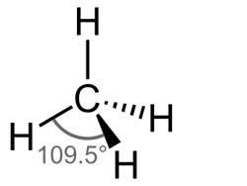
PCl₃ | 26 | 2 | 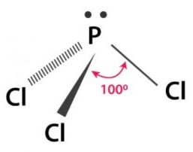
CO₂ | 16 | 0 | 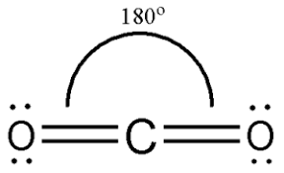
NH₃ | 8 | 2 | 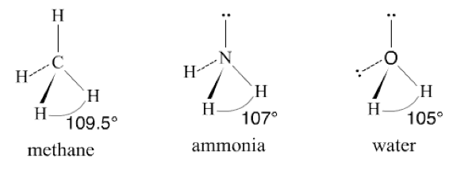
BH₃ | 6 | 0 | 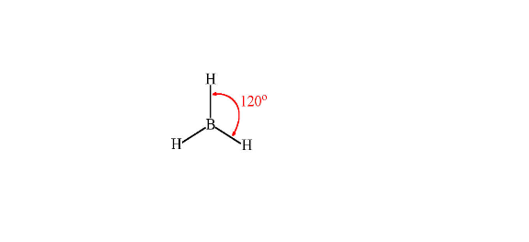
BeCl₂ | 16 | 0 | 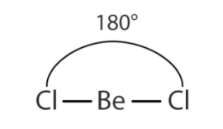

Bonding and Polarity
As much as the chemical bond is characterized as covalent or ionic, they are hardly fully formed.
Some molecules form covalent bonds by fully sharing their valence electrons to form stable compounds. Ionic bonds are formed when metallic atoms react with nonmetallic but not all are ionic some form covalent bonds for instance BeCl₃. The bond between nonmetals is said to be a covalent bond.
Nonpolar covalent bonds are bonds formed when two atoms equally share electrons to form a compound. But in a polar covalent bond, the atom with the highest electronegativity attracts more electrons more strongly. This leads to unequal sharing of electrons giving rise to pole charges. Since the formation of a bond in most cases is determined by the electronegativity of an atom. That means each atom has its electronegative value. The values show the power to attract electrons from other atoms and form bonds. When an atom has an electronegativity value difference greater than 1.9 the bond is said to be more ionic than covalent. And when the difference is 1.9 or less the bond formed is said to be covalent. When the electronegative difference is 1.9 to 0.5 this shows polar covalent but when the difference is less than 0.5 then it is nonpolar covalent. The table below shows an example of how to approximate the bond polarity of elements and determine the bonds formed
Bonding pair | Electronegative difference | Type of bond | Type of Polarity
C - H | (2.55-2.12) = 0.4 | covalent | nonpolar
F- F | (4.0-4.0) = 0.0 | covalent | Non polar
P-Cl | (3.16-2.19) = 0.97 | Covalent | polar
The table below shows the electronegativity difference, the polarity, and bond type of the different compounds used in an experiment.
Data table 3
Chemical formula | Unique bonds between atoms | Electronegativity difference for each unique bond | Bond classification | Is it polar or non-polar
CH₄ | C-H | 0.4 for C-H | C-H is a nonpolar bond | CH₄ is nonpolar
PCl₃ | P-Cl | 0.97 for P-Cl | P-Cl is polar | PCl₃ is polar
CO₂ | C-O | 0.89 for C-O | C-O is polar | CO₂ is polar
NH₃ | N-H | 0.84 for N-H | N-H is polar | NH₃ is polar
BH₃ | B-H | 0.16 for B-H | B-H is non-polar | BH₃ is nonpolar
BeCl₂ | Be-Cl | 1.59 for Be-Cl | Be-Cl is polar | BeCl₂ is polar

Reference

Mark B Fischer, B.S. Chemistry, U of California; Ph.D. Inorganic Chemistry, U of Wisconsin-Madison

SEPR Model of Molecular Geometry by Ronald J Gillespie, Istvan Hargittai
John Emsley, The Elements, 3rd edition. Oxford: Clarendon Press, 1998.
Pauling, Linus (1960). The Nature of the Chemical Bond.

